

Cairo University   
Faculty of Computers and Information

**CS251**

**Software Engineering I**

Educational Games

Software Design

X-team

December 2016

Contents

Team............................................................................................................................................3

Document Purpose and Audience.................................................................................................4

System Models. ......................................…...................................................................................5

I. Class diagrams......................................................................................................................5

II. Sequence diagrams..............................................................................................................6

Class - Sequence Usage Table......................................................................................................…9

Team

|  |  |  |  |
| --- | --- | --- | --- |
| **ID** | **Name** | **Email** | **Mobile** |
| 20140135 | Sara Tarek Farid | [Saratarek224@hotmail.com](mailto:Saratarek224@hotmail.com) | 011118639266 |
| 20140314 | Youmna Ashraf Mohamed | [youmnaashraf968662@gmail.com](mailto:youmnaashraf968662@gmail.com) | 01125322537 |
| 20140316 | Yomna Mansour Mohamed | [Youmnamansour15@gmail.com](mailto:Youmnamansour15@gmail.com) | 01123914441 |
| 20140303 | Hadeer Mohamed Awad | [hadeer.awad212@gmail.com](mailto:hadeer.awad212@gmail.com) | 01144431554 |

# Document Purpose and Audience:

Purpose:

The purpose of this document is to describe the design of the application's software by describing the structure of the system and all possible interactions. It also includes class diagrams and sequence diagrams.

Audience:

This document target the project manager and Developers.

class diagram

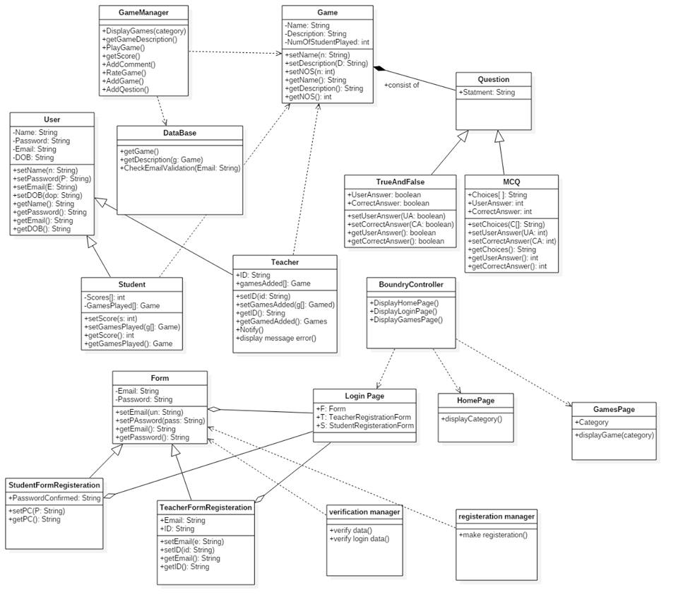

sequence diagram

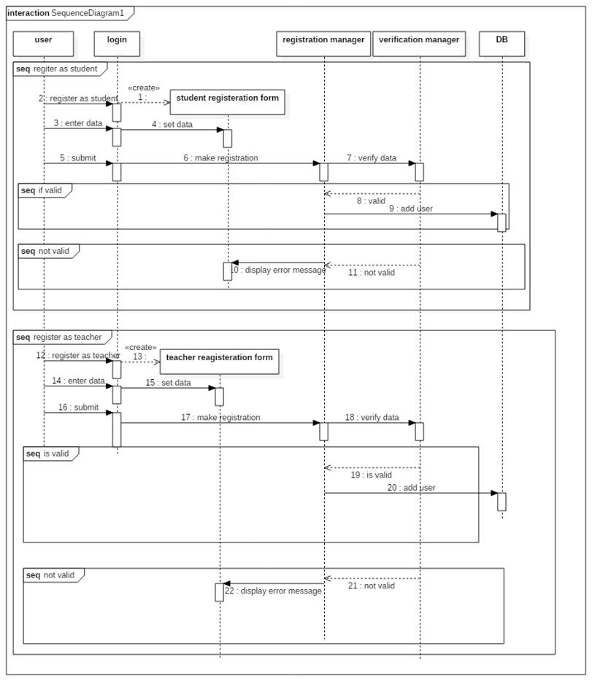

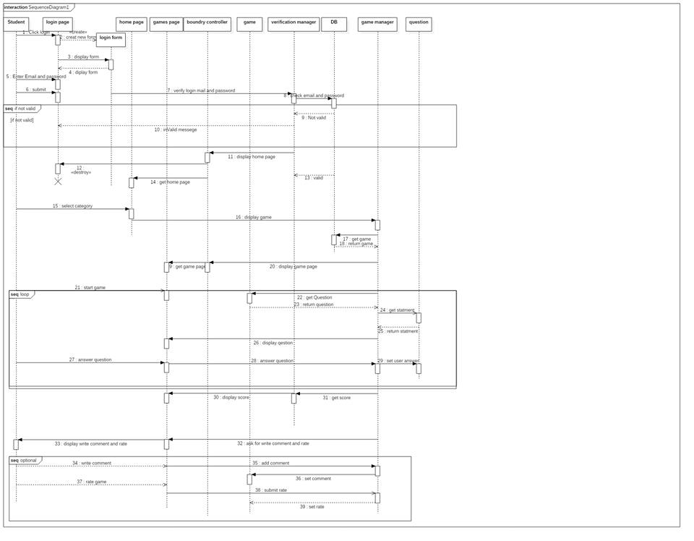

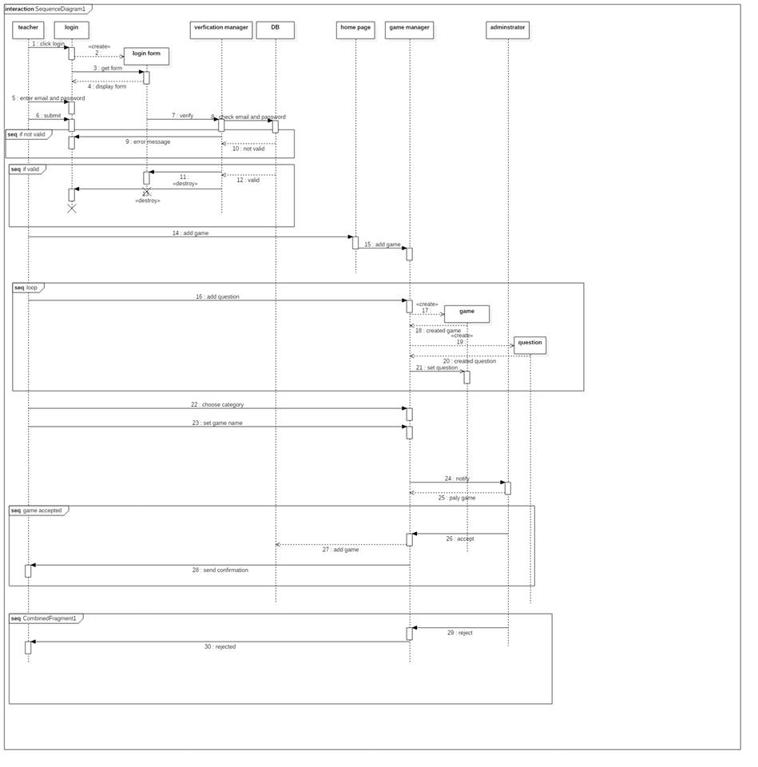

|  |  |  |
| --- | --- | --- |
| **Class name** | **ID** | **Description** |
| **Game manager** | 1 | It manages everything happen in game class and the functions will done in the game |
| **Game** | 2 | It contains the attributes of the games and the description of each game |
| **user** | 3 | It contains the name and email and password and the information of the user and it and it is either student or teacher |
| **Database** | 4 | This class controls the database |
| **Question** | 5 | It represent the type of the game if it is MCQ of true and false |
| **Form** | 6 | This class contains the information that display to user when he wants to register and there is two forms one if the user is student and the other if it is teacher |
| **Boundary Class** | 7 | It displays home page and login page and game page to the user |
| **Verification manager** | 8 | It verify data and login data |
| **Registration manager** | 9 | It makes register |